Bangladesh Medical Association (BMA)
List of Life Member-6
03. BMA Barguna Branch

Sl No | Voter No | Voter Details
1 | Voter No  LM-0300001  No Image | DR. MIZANUR RAHMAN  F/Name:  M/Name:  BM & DC Reg. No:  NID:  Cell:  Address:  Blood Group:  TRANSFERED to BMA Dhaka City  LM-1405543
2 | Voter No  LM-0300002 | DR. MD. ABDUL KHALEQUE  F/Name: Abdul Ghani Howlader  M/Name: Achia Khatun  BM & DC Reg. No: 12482  NID:  Cell: 01726736051  Address:  Blood Group: A+
3 | Voter No  LM-0300003  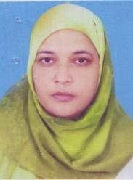 | DR. MST. MAHMUDA  F/Name: Abdul Majid Mia  M/Name: Mst. Hamida Begum  BM & DC Reg. No: 22032  NID:  Cell: 01730161212  Address: Sher -E- Bangla Road, Barguna  Blood Group:
4 | Voter No  LM-0300004 | DR. MD. RUSTUM ALI  F/Name: Late Elem Uddin Sardar  M/Name: Late Barujan Bibi  BM & DC Reg. No: 15353  NID:  Cell: 01191434213  Address: Lhanta Bhaban, Bazar Road Barguna  Blood Group:
5 | Voter No  LM-0300005 | DR. MD. AKBAR HOSSAIN.  F/Name: Md. Isahaque Hossain Miah.  M/Name: Mst. Zobaida Isahaque.  BM & DC Reg. No: 19834  NID: 0422807116851  Cell: 01711119803  Address: ASST. PROF ,DEPT OF OBSI GYNAE SBMC BARISAL.  Blood Group: AB+
6 | Voter No  LM-0300006  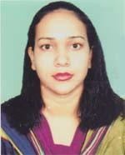 | DR. SARMIN AKHTER.  F/Name: Md. Ashraf Ali .  M/Name: Mrs, Rahima Begum  BM & DC Reg. No: 46454  NID: 19830695112191804  Cell: 01712731321  Address: 7/D, DOCTORS QUARTERS ,SBMCH, BARISAL.  Blood Group: B+

